Good day @ **Bailey Motor Equipment Co.**

I am the international sales representative of **SP Carburetor** (**赛普机电**) in Chongqing, China.

**SP Carburetor** is the second-largest carburetor manufacturer in China and we ship to dozens of countries around the world.

We specialize in carburetor design, research and manufacturing and are able to ship with any specifications and in any volume.

Here is a list of some of some of our products and clients: www.spcarb.com/gallery.html

Please feel free to contact me if you have any questions.  
  
Looking forward to hearing from you.

*Don Hartig*  
**International Exports - SP Carburetor (赛普机电).**

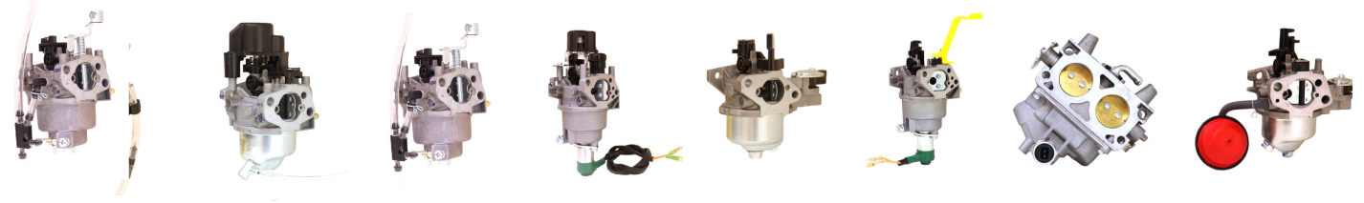F:\Websites\spcarb\images\SPCarb Logo.PNG